4th Circle Conference of Gujarat at Silvassa on 22nd and 23rd September 2016.
4th Circle Conference of Gujarat was conducted at Silvassa . Which is situated under Daman of union territory of India. The Conference was conducted in Town hall of Silvassa with full pomp and show. It begun with Flag Hoisting at 11.00AM on 22-09-2016, The National Flag was hoisted by Com. Chandeshwar Singh GS NFTE and the union flag was hoisted by Com.H.R.Tiwari CHQ vice President and Circle president of Gujarat Circle. More than 250 delegates were participated in the delegate session and all the district secretaries and some of the Circle office bearers also participated in debate on circle secretaries report and the accounts. Which was passed by the house unanimously. An open session was organized on23-09-2016, with full gathering of workers. The session was attended by G.S. and the DGMs and others of Balsad . The open session was addressed by the representative of local MP and other social and political leaders. The circle secretary addressed the meeting and reported the organization position of union in Gujarat circle. G.S. in his speech exhorted all the H.R. issues and informed, that the NFTE BSNL is striving hard for betterment of company and its workers, he added that we have opened the door of PLI (Bonus) which was closed after 2009. He explained how the HRA on 78.2 % IDA and 78.2% IDA to pensioners was achieved including removal of 60:40% condition in pension. The open session was conclude after vote of thanks by Com.H.R.Tiwari President. After lunch break the president declared the agenda of election of office bearers for the year 2016-2019. Com.H.R.Tiwari Com.N.J.Bhatia and Com.P.K.Mistry were elected as Circle President, Secretary and Treasurer respectively. The reception committee headed Com.Morya was appreciable for grand success conference.
PHOTO Of Conference Below. 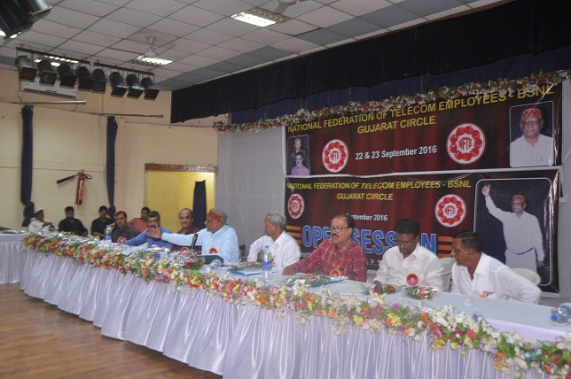
Com. C. Singh Addressing Open Session.
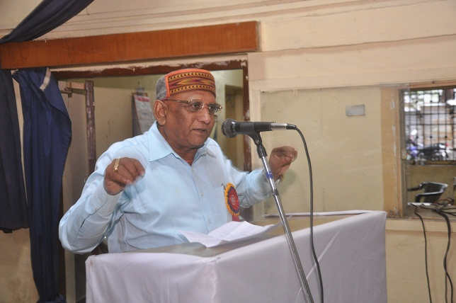
Com. N.J.Bhatia C.S. Gujarat Addressing Open session.
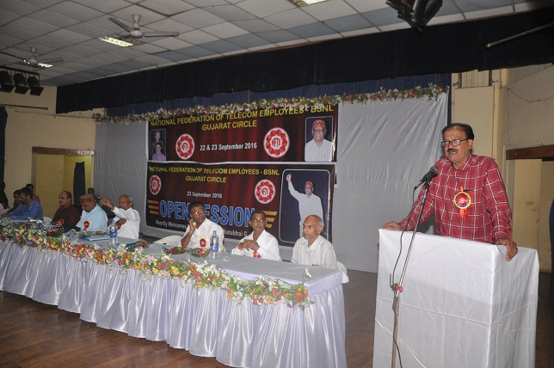

Audience in Open session.

